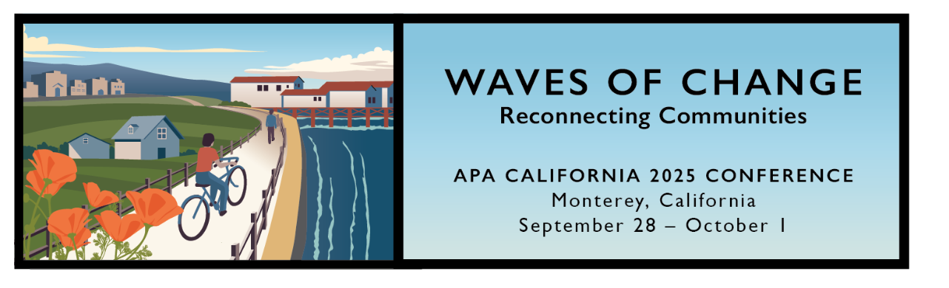

APA California 2025 Conference Webpage located here

Save the Date:
Early Registration Opens in June!
Monterey is uniquely situated at the intersection of land and sea, where the beauty of the coastline offers the perfect backdrop for this year’s theme – “Waves of Change.” Join us as we deep dive into the tides of innovation and explore how inspiration and collaboration can shape the future of planning in our communities. We can’t wait to see you there!

2025 Registration Prices
Registration Type | Early-Bird | Regular
Member | $682.50 | $782.50
Young Emerging Planner (YEP) | $430.50 | $530.50
Retired | $341.25 | $441.25
Student | $131.25 | $181.25
Non-Member | $866.25 | $966.25
One-Day* (Member) | – | $270
One-Day* (Non-Member) | – | $300
*One-Day registration available Monday/Tuesday ONLY
Speaker Registration
Session Day ONLY | – | $315
Full Conference | – | $525

