August 14, 2023

Stevens Creek Subaru
brian@stevenscreeksubaru.com
reza@stevenscreeksubaru.com
3225 Stevens Creek Blvd
San Jose, CA 95117

RE: Violation of Approved Rezone and Use Permits (File No. PLN2015-11350 and PLN2016-11888)

To Whom it May Concern:

It has come to the City’s attention that the required trash enclosure for the above approved and completed project was never constructed. Please be advised, that per the conditions of approval (P3 and ST1) below and in the attached Conditions of Approval, a trash enclosure is required for the project. Any modification to the trash enclosure location requires an amendment to the Use Permit.
P3. Any modification to the approved proposal shall require an amendment to the Use
Permit subject to Planning Commission review and approval prior to commencement of
the proposed changes.

ST1. Submit a solid waste collection plan to meet the requirements. Please contact Street Department at 408-615-3080 for guidelines. (a.) Solid Waste enclosure must provide a minimum unobstructed inside opening of 12' and have minimum inside dimensions of 18.5' by 10.5'.
Recent communication with the City of Santa Clara Public Works Department and Mission Trail Waste Systems, have indicated that the location of your trash enclosure as shown on your permit plans does not meet Mission Trail requirements for trash pickup. Currently, solid waste from 3225 Stevens Creek Boulevard is relocated to 3155 Stevens Creek Boulevard for service. However, each entity must subscribe to and maintain solid waste services independently. This requires you to submit a new solid waste collection plan for review.

One possible option would be to stage the trash bins out on Cecil Avenue. While this option works for Mission Trail, the Use Permit for the site would need to be amended to allow for this operation as the following condition prohibits trash pickup on Cecil Avenue.

P19. No loading, unloading, deliveries, trash/recycling pick-up, vehicle staging, vehicle parking, vehicle/site service, or other site function shall occur on Cecil Avenue or other nearby residential streets, with the exception of oil and other fluid extraction and supply to
the business may occur on Cecil Avenue between the hours of 8:00 a.m. to 5:00 p.m. Oil and other fluid extraction and supply on Cecil Avenue shall occur no more than one time per week. The business operator shall maintain a log of activity for the oil and other fluid extraction and supply. Said log shall be furnished to the City upon request

Another option would be to stage solid waste containers on Stevens Creek Boulevard. Mission Trail Waste Systems has approved of this area, but for safety reasons a portion of your frontage would need to be painted red. To initiate this process a formal written request on company letterhead must be forwarded to the City of Santa Clara Transportation Manager, Steve Chan, at SChan@SantaClaraCA.gov.

The red curb option on Stevens Creek Boulevard could be set up as a temporary solution while the amendment to allow solid waste collection service on Cecil is pursued.

To allow for solid waste services and resolve this violation the following must occur:

- Application for a Minor Amendment to an Approved Permit, to address the lack of constructed trash enclosure,
- Submittal of a formal written request on company letterhead requesting a red curb be installed on Stevens Creek Boulevard to allow Solid Waste collection and/or
- Application of a Use Permit Amendment if condition modification is necessary (to allow service on Cecil Avenue)

Corrective action is necessary on your part to ensure that the conditions of approval are abided by or amended, and that mandatory solid waste services continue. Failure to address these issues may result in a citation.

Should you require more information or assistance regarding this notice, please contact me at Lxavier@SantaClaraCA.gov.

Sincerely,

Lesley Xavier
Planning Manager

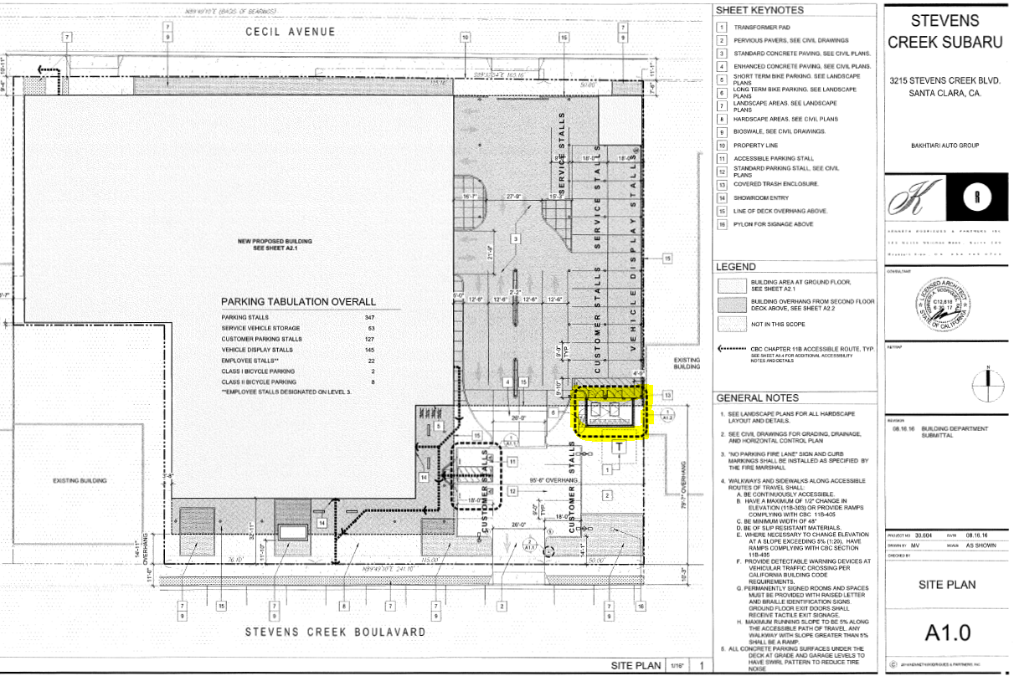
Approved Architectural Plans:

